PHP2Shell Lab Writeup
TryHackMe lab writeup | Giancarlos Figueroa | October 2026
CVE-2026-109618(memory disclosure) CVE-2026-109619(remote code execution)

This is my writeup of the PHP2Shell room on TryHackMe. I worked through the lab against a vulnerable PHP server and wanted a clear record of what the attack actually does and, more importantly for where I am headed, how a defender would catch it. I kept the exploit explanation at the concept level. The goal here is understanding, not a copy paste attack guide. The diagrams below are from the room, and the terminal screenshots are from my own run.
The short version
PHP2Shell is the nickname for two critical PHP vulnerabilities that got emergency patches on October 21, 2026. What makes it a big deal is where the flaw lives. It is not in WordPress, Drupal, or any application. It is in the PHP runtime itself, the engine that runs the code. That means an unauthenticated attacker can run commands on the server before the website's own code even starts, and a perfectly clean, well-written application gets no protection from it.
In the lab the target page was one line that prints OK. It has no login, no upload form, no database, and no bug of its own. The attack still worked, because the attack is against PHP, not the page.
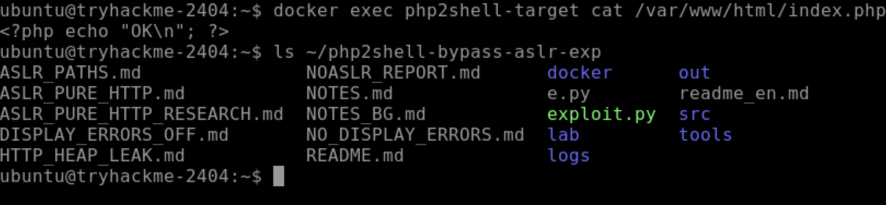
The entire target application: one line that prints OK, plus the exploit toolkit staged on the box.
Confirming the target
First step in the lab was just confirming what I was dealing with. The vulnerable server runs as a container, and checking the PHP version showed 8.4.26, one release short of the 8.4.27 fix, so it is vulnerable.
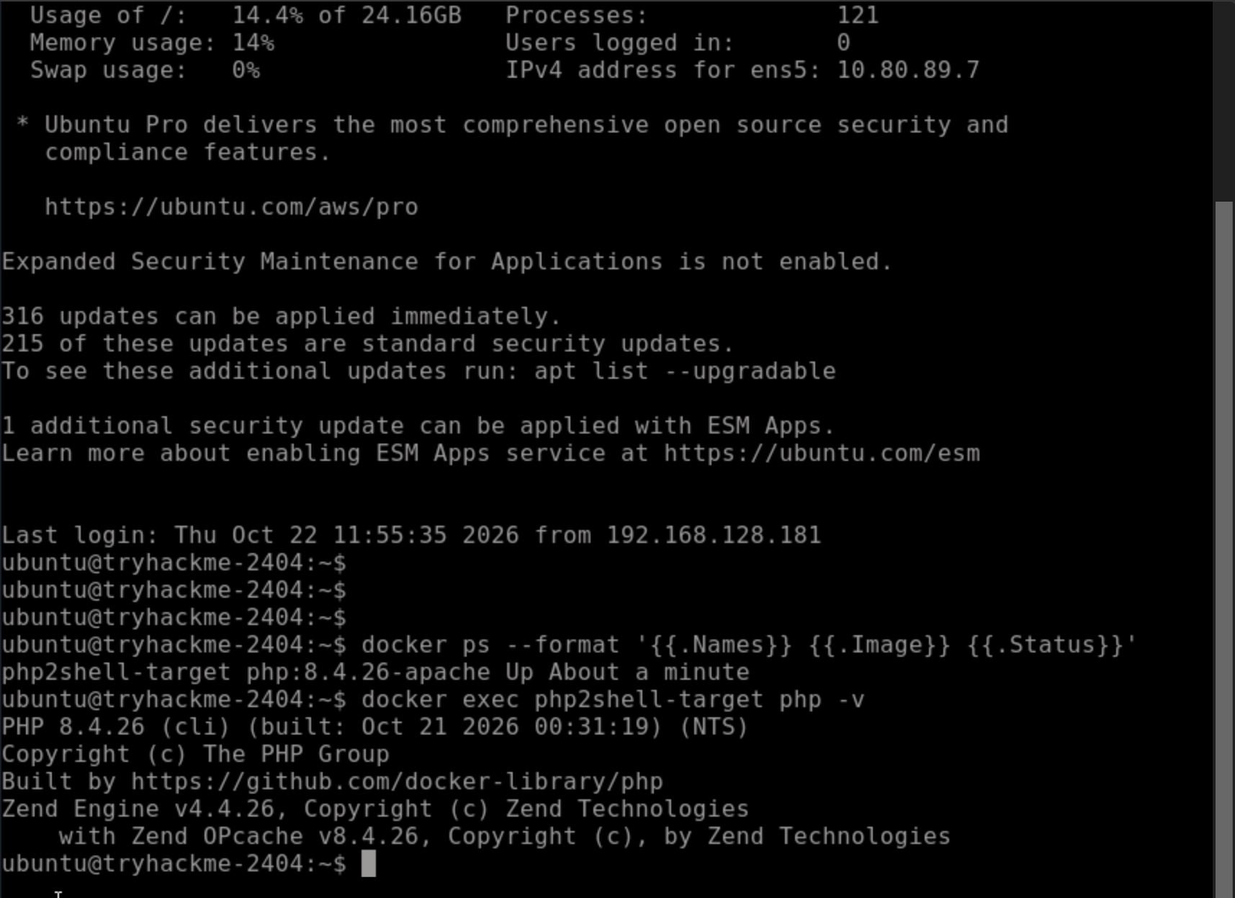
docker ps and php -v confirm PHP 8.4.26 running under Apache, one version behind the patch.
How the attack works
The whole chain is a handful of steps, and every step is just an ordinary file upload request. Here is each one in plain terms.
1. The foothold: upload progress runs before your code
PHP has a feature that reports how far along a file upload is, so a page can show a progress bar. While PHP is still reading the upload off the wire, it writes the upload status into the user's session. The key detail is the timing. This happens during body parsing, which is one of the first things PHP does, long before it runs the actual script the URL points to.
To reach it, an attacker just sends a file upload that includes a field named PHP_SESSION_UPLOAD_PROGRESS. No login, no session start in the page, no application logic needed. Any URL that accepts a POST is enough. That is the foothold.
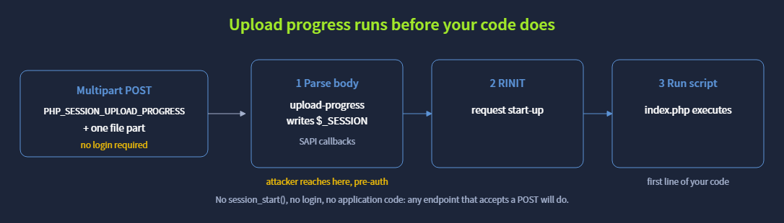
The upload progress code runs during body parsing, before RINIT and before the script executes.
2. The bug: a memory bailout skips the cleanup
PHP limits how much memory one request can use. When a request goes over that limit, PHP cannot continue, so it takes an emergency exit called a bailout and jumps back to a safe point, abandoning whatever it was doing.
Freeing memory is really two steps: hand the memory block back, then erase the pointer that refers to it. If the out of memory crash lands between those two steps, the bailout runs and the second step never happens. You are left with a pointer that still points at memory that is no longer valid. That is a dangling pointer (CWE-824).
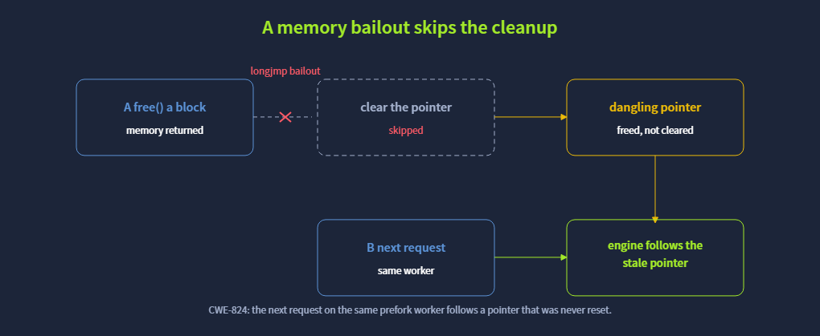
The bailout skips clearing the pointer. On the same prefork worker, the next request follows the stale pointer.
On its own this would be harmless, because the request is already dead. What makes it dangerous is the server model. Under Apache prefork with mod_php, one worker process handles request after request without restarting. So, the stale pointer does not disappear. It sits in the worker, and the next request to hit that same worker trips over it. The attacker controls what gets loaded into that freed space in the second request, which means they control what the pointer now points at.
3. Reading memory: the cookie header leaks the server's memory
This is the first CVE (CVE-2026-109618). The stale pointer gets reused as a session ID string, but with its length field inflated far past the real 32 bytes. When PHP sends the session cookie, it reads that oversized string and dumps it into the Set-Cookie: PHPSESSID response header. The attacker reads the reply and gets back up to about 67 KB of the worker's memory. In the real world that memory can hold other users' passwords, session cookies, API keys, even TLS private keys. For the exploit, it holds the memory addresses it needs.
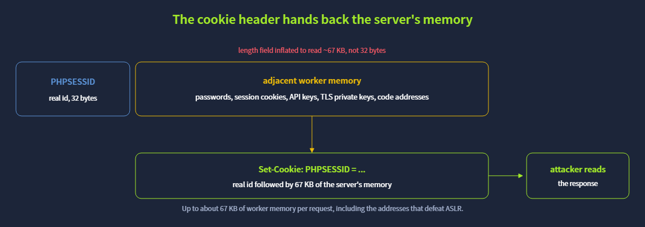
An inflated length turns a 32 byte session ID into a 67 KB read, returned straight out of the Set-Cookie header.

The first run end to end: curl confirms the target still just prints OK, then the exploit leaks the heap and libphp bases and lands code execution, proving id as uid=33(www-data).
The exploit runs this leak twice. Once to find where the heap is, and once to find where libphp (PHP's own engine code) is. Together, those two leaks defeat ASLR, the defense that randomizes where things sit in memory. The addresses change on every run, so the attack does not guess them, it just reads them out fresh each time.
4. Running code: a forged destructor fires system()
This is the second CVE (CVE-2026-109619). Now the attacker reoccupies the freed memory one last time, not with data to read, but with a forged internal structure whose cleanup function pointer has been set to the address of system(), the function that runs shell commands. That address is known because the leak in step 3 found where libphp lives.
When PHP does its normal end of request cleanup, it thinks it is calling a harmless destructor and instead calls system() with the attacker's command. The command runs as the web server user. Nothing outside PHP is needed for this, no external gadgets or chains. The engine's own cleanup machinery is turned against it.
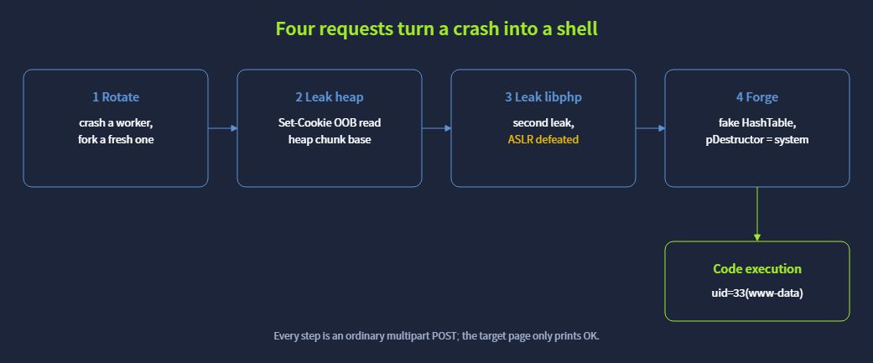
Four requests: rotate a worker, leak the heap, leak libphp to defeat ASLR, then forge a destructor pointing at system().

In my run this proved out as uid=33(www-data), and the whole chain finished in under ten seconds. That is remote code execution against a server with no application vulnerability at all.
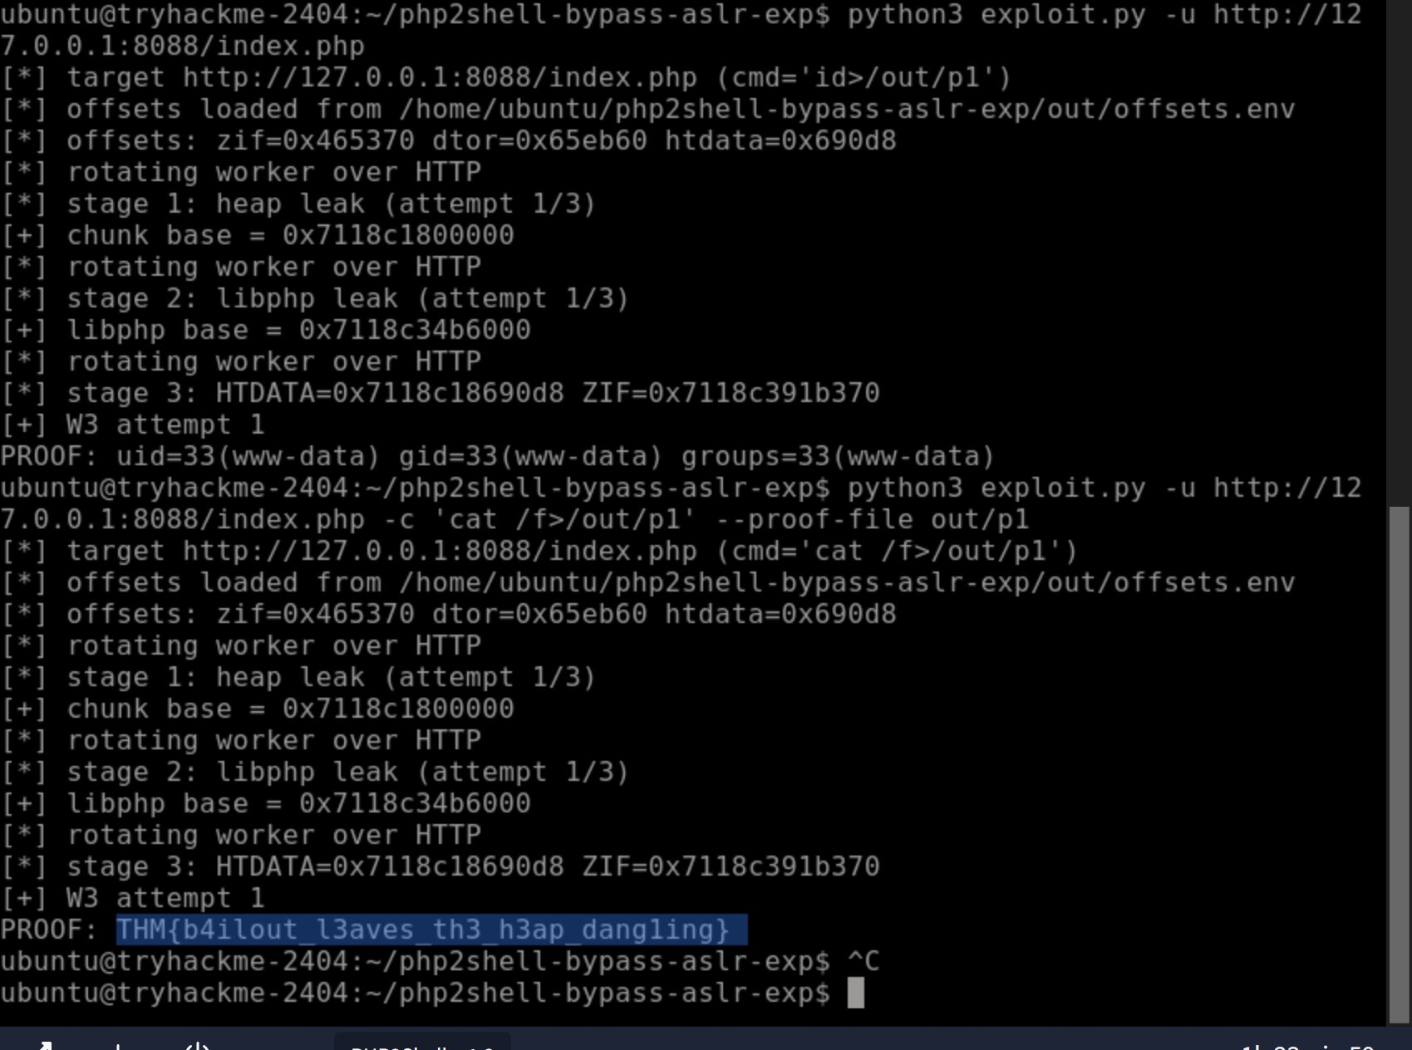
My exploit run: two memory leaks (chunk base and libphp base), then code execution. First run proves id, second returns the flag.
5. One note on www-data
The code runs as www-data, the low privilege account the web server runs as. That is the starting point, not the finish. To take full control of the box, an attacker would need a second step, privilege escalation, using some other misconfiguration or vulnerability. So in a real incident, www-data running unexpected commands is the first thing you catch, and the next question is always whether they escalated from there.

The defender's view
This is the part that matters most for SOC and IR work, so I spent the most time on it.
Why you cannot fix this at the application layer
Because the bug is in the runtime, updating WordPress, Drupal, Joomla, or Laravel does nothing. Those sit on top of PHP, and the broken code is underneath all of them. You also cannot code review your way out of it, since the application code is not where the flaw is. The only complete fix is to patch PHP itself and restart every worker so no process keeps running the old code.
Fixed versions:
- PHP 8.5.12, 8.4.27, 8.3.36, or 8.2.35, depending on which release line you run.
- After patching, restart all workers. Patching the files on disk is not enough if the old worker is still running in memory.
Interim measures until you can patch
None of these is a full substitute for patching, but each one breaks a different link in the chain.
Measure | What it does
session.upload_progress.enabled = 0 | Removes the trigger the attack relies on. Restart workers after.
opcache.enable = 0 | Frustrates the code execution path.
fatal_error_backtraces = 0 | Addresses the RCE specifically, on PHP 8.5.
Reject multipart/form-data at the edge | Blocks the delivery method, but breaks real file uploads too.
Run PHP with least privilege | Limits the damage if the chain does land.

The one defense that does not help
A web application firewall that runs as a PHP module is useless here. A module based WAF only inspects traffic after PHP hands control to the application, but this attack finishes before the application ever runs. The malicious work is already done during body parsing, so an in process filter never gets to see it. Protection has to sit either in the patched runtime or at a layer in front of PHP, like a network edge WAF.
What to detect
The attack leaves a few distinctive marks. Any one is worth alerting on while patching is in progress, and the combination is a strong signal.
- Abnormally large PHPSESSID values in Set-Cookie response headers. A normal session ID is short and fixed length. A memory leak response carries tens of KB. This shows up in the response, not the request, which is worth remembering.
- Large multipart POST bodies with very high field counts that carry the PHP_SESSION_UPLOAD_PROGRESS field.
- PHP worker crashes and out of memory errors in the logs, which is the memory exhaustion that drives the bug.
If they got code execution: post exploitation to watch for
If an attacker lands as www-data, the highest value detection idea ties right back to the runtime versus application point. A web server process should almost never spawn a shell or a recon command. Apache launching bash, or www-data running id, whoami, or reading /etc/passwd, is deeply abnormal. That parent to child relationship, web server to shell to recon command, is one of the most reliable signals there is, and it is the kind of thing I would write a Defender or KQL detection for over DeviceProcessEvents.
- New or modified files in the web root, especially www-data writing a .php file.
- Unexpected outbound connections from the web server process, which can mean a reverse shell.
- New cron jobs, services, or startup changes, which point to persistence.
- www-data suddenly acting as another user, which points to privilege escalation.
What I took away from this
This October the number of cyberattacks seems to have jumped, and PHP2Shell is the latest example. It is a dormant flaw that has been in the wild since 2012 and is only now getting patched out. What stands out to me is the role AI played. It basically speedran the work of turning an old, hard to exploit bug into a working attack against software that much of the internet runs on. That should ring alarm bells for defenders, and it is a sign to start preparing environments for the worst case instead of assuming old bugs will stay dormant.
The lab also drove home how much of defense is making fast calls under pressure. While something like this is getting patched, what do you actually do in the meantime? Do we isolate the container, or keep it online while the patch is rolled out? What do we lose by taking it offline immediately? There is no clean answer, and those are tough decisions that have to be made quickly.
Overall this was a great environment to work through, and it is the kind of thing that helps me stay current on the latest threats.

